34.66: 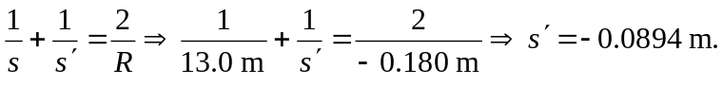
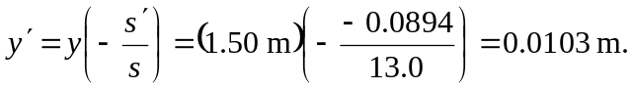
b) The height of the image is less then 1% of the true height of the car, and is less than the image would appear in a plane mirror at the same location. This gives the illusion that the car is further away then “expected.”

